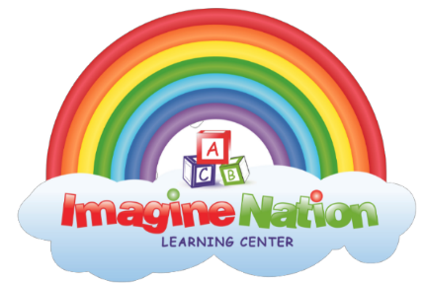
Infant Daily Feeding Schedule
Child’s Name: ___________________
Date: __________________________
Address: _______________________
Phone: _________________________
Child’s Birthday: __________________

Formula
Check One:
- Bottle What temperature does your child Prefer their bottle? Cold, Room temp,or Hot
- Breast milk How often does your child drink a bottle? ________________
How many ounces does your child drink? ________________
Juice
What Flavor does your child drink? ______________________________

How often can your child have juice? _____________________________

How much does your child drink? ________________________________

Food
What kind of food does your child eat? Solid or Baby food

What kind of solids or baby food does your child eat? ___________________________

How often does your child eat solids or baby food? _____________________________

How much Solids or baby food does your child eat? ____________________________

Are there any special instructions we should know before feeding your child solids or baby food? ______________________________

Sleeping
What is your child’s sleeping Schedule: _________________________________________________________________

Does your child take a pacifier? Yes or No

What brand of diapers does your child wear? ____________________________________

What brand of wipes does your child use? ______________________________________

What brand of diaper rash cream does your child use? ____________________________

Is there any other information you think we need to know about your child? ______________________________________________

Parents Signature X_____________________________ Date____________________
Date
Initials

